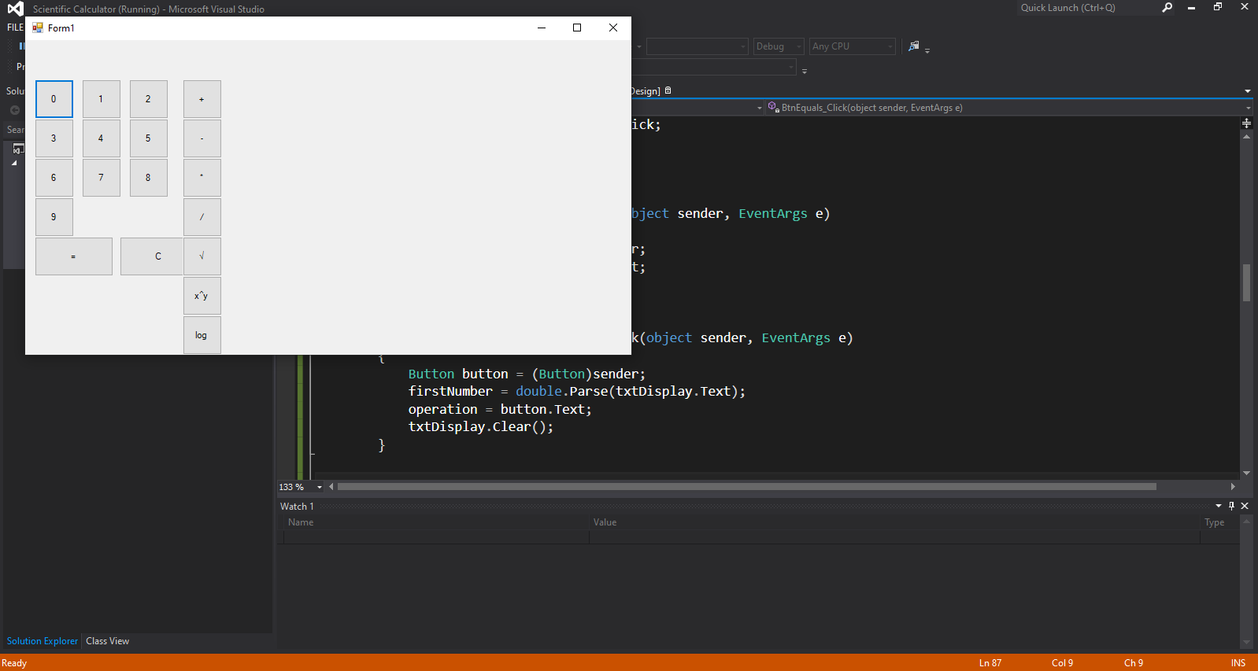

Output:  
  
  
  
  
github: